COMMUNITY ENGAGEMENT in BROADBAND and DIGITAL EQUITY PLANNING
This worksheet is designed to help your team consider how you will engage community members in shaping broadband and digital equity plans. Community engagement is the process of involving the public in problem-solving, planning, policy-setting, and decision-making.
Your team should discuss,
- WHO do you need to engage in your planning effort?
- WHY is it important to engage these local partners and community members?
- WHAT do you want to accomplish by engaging them?
- HOW can you effectively engage them?

WHO
Broadband planning efforts across Wisconsin have a focus on ‘internet for all’. This means that all Wisconsinites have access to affordable broadband service and equitably share in the benefits of broadband technology. Who you engage will also be determined by the demographic makeup of your community. There are a few individuals and groups you will want to engage in your broadband and digital equity planning efforts. Those include:

Local partners: organizations in the community with an interest in broadband and digital equity.

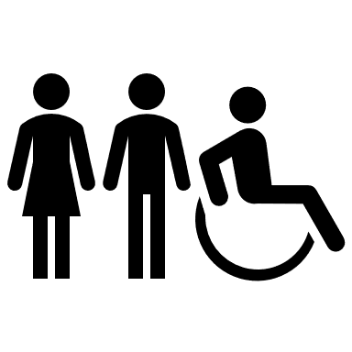
Community members: individuals or groups in the community who can provide perspectives, opinions, and experiences that will inform your broadband and digital plan.

TAKING ACTION – PUTTING IT INTO PRACTICE
As you explore who to engage in your planning effort, we recommend this Engage Local Partners and Engage Community Members worksheet which is designed to help you think about who to engage in your broadband and digital equity planning efforts.

WHY
There are two main reasons why community members should be engaged in your broadband and digital equity planning efforts.
Community engagement produces better results. This is true because community members bring to the table their unique knowledge and expertise. They can articulate their needs and offer solutions to those needs.
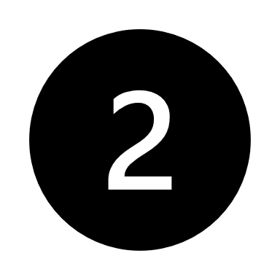
Community engagement produces more engaged community members. When invited to be a part of your broadband and digital equity planning, community members become more informed and see how they can contribute to solutions.

TAKING ACTION – PUTTING IT INTO PRACTICE
You may have some additional reasons why it is important to engage community members. As a planning team, have a conversation about the following question. Why is it important for us to engage community members in our broadband and digital equity planning?

WHAT

There are five purposes for engaging community members in your broadband and digital equity planning. Along with each purpose, there is a promise that you are making to the community.

AWARENESS
Purpose: Make the community aware of your broadband and digital equity planning effort.
Promise: We will keep you informed.

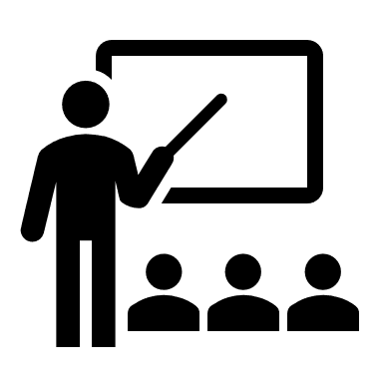
EDUCATION
Purpose: Provide the community with information to assist them in better understanding broadband and digital equity needs, concerns, solutions, and plans
Promise: We will try to help you understand.

INPUT
Purpose: Obtain community feedback on broadband and digital equity needs, concerns, solutions, and plans.
Promise: We will provide opportunities for your input, and feedback on how your input influenced decisions.

INTERACTION
Purpose: Work directly with the community to ensure that their issues and concerns are consistently understood and considered.
Promise: We will work with you to ensure your concerns are directly reflected in the alternatives, strategies, and plans; and provide feedback on how your input influenced decision
PARTNERSHIP
Purpose: Place decision-making responsibilities in the hands of the community.
Promise: We will work to implement what you decide.

TAKING ACTION – PUTTING IT INTO PRACTICE
You will likely find that during your broadband and digital equity planning efforts, you focus on several if not many of these engagement purposes. As a planning team, have a conversation about the following question: What do we want to accomplish by engaging the community in our broadband and digital equity planning? Which engagement purposes and promises are important for us to focus on?

HOW
For each community engagement purpose (awareness, education, input, interaction, and partnership) there are several different methods or tools you can use. The table below shows methods in relationship to their usefulness for accomplishing each engagement purpose.

Method | Awareness | Education | Input | Interaction | Partnership
Direct mail | High | Moderate
News releases, mass, and social media | High | Moderate
Displays and exhibits | High | High
Public educational meetings | Moderate | High
Websites | Moderate | High | Possible
Open Houses | Low | Moderate | High
Public Hearings |  | Moderate | High
Surveys |  |  | High
Focus Groups |  |  | High
Asset Mapping |  | Moderate | High | High | High
Community Forum |  | Moderate | Moderate | High
Citizen Advisory Committee |  |  | High | Low-Moderate
Visioning |  |  | High | High
Citizen Planning Committee |  |  | High | High | High

TAKING ACTION – PUTTING IT INTO PRACTICE
You will likely want to use several different methods to engage community members. As a planning team have a conversation about the following question: Based on (1) our engagement purposes, (2) what we know about our community, and (3) the time and resources we have available, which engagement methods do we want to use?

YOUR COMMUNITY ENGAGEMENT PLAN
Now that you know Who, Why, What, and How you will engage community members in your broadband and digital equity efforts, you can put together a simple plan to guide your community engagement efforts. What that plan looks like is unique to each community. That said, there are a few guidelines to consider as you develop your community engagement plan:
Multiple ways to engage.
Community members should be given several opportunities and ways to engage. This allows them to engage in ways that they find valuable, and at times and in places that work for them.
Equitable access.
You should remove as many barriers to participation as possible. This could include making sure the location for an open house is wheelchair accessible, having an interpreter available during a focus group, and making surveys available at public locations such as schools and the library.
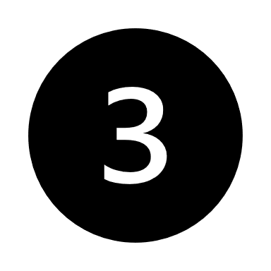
Communicate how input was used.
When you ask for ideas, input, and feedback from the community, it is important to tell them how you used that information.
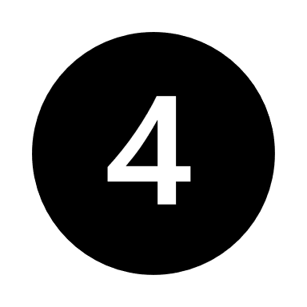
Celebrate milestones.
Part of engaging the community includes celebrating milestones. Celebrating milestones helps people see what is working, strengthens relationships and engagement, and creates positive momentum.

Here is an example of what a broadband and digital equity community engagement plan might look like (next page).

Phase | Dates | Purpose | Method | Who to Engage
Pre-Planning | January-February | Public Partnership -> Establish community engagement immediately by forming a committee | Citizen Planning Committee | Cross-section of affected community members
Pre-Planning | March | Awareness -> Let community members know we have started a local broadband and digital equity planning process. | News Release & Social Media Posts | Everyone
Initial Community Input | April-May | Public Input -> Understand needs related to broadband and digital equity. | Digital and Paper Surveys | Everyone
Initial Community Input | June | Public Partnership -> Analyze the initial input and determine what additional information is needed and from whom. | Citizen Planning Committee | N/A
Initial Community Input | July | Public Education -> Share what the committee has learned about community broadband needs. | Website, Public Education Meeting | Everyone
Additional Community Input | August-September | Public Input -> Gain a deeper understanding of needs and explore possible solutions that can inform the broadband and digital equity plan. | Focus Groups | Community members who can add insight into the needs identified during initial community input.
Additional Community Input | October | Public Interaction -> Have community members identify resources in the community that can support broadband and digital equity goals. | Asset Mapping | Cross-section of community members who have a good understanding of the community and its resources.
Additional Community Input | November | Public Partnership -> Analyze the focus group and asset mapping information. | Citizen Planning Committee | N/A
Plan Development | December | Public Awareness -> Let community members know where the planning process is at, and what the committee has learned so far. | News Releases & Social Media Posts | Everyone
Plan Development | January-February | Public Partnership -> Committee members shape three plan alternatives to share with the community. | Citizen Planning Committee | N/A
Plan Selection | March | Public Education -> Share with the community the three plan options identified by the committee. | Public Education Meetings & Website | Everyone
Plan Selection | April | Public Interaction -> Ask community members to share which plan option they prefer and offer final input. | Advisory Vote via Digital and Paper Survey | Everyone
Plan Finalization | May | Public Partnership -> Committee reviews community input and makes a final plan recommendation to the local government. | Citizen Planning Committee | N/A
Plan Finalization | June-July | N/A -> Local government takes recommendation and does final legal review and adoption. | N/A | N/A
Plan Completion | August | Public Awareness -> Communicate to the public that the plan is complete and how their input was used. | New Releases & Social Media Posts | Everyone
Plan Completion | September-October | Public Education -> Share with community members how the final plan affects them and the resources available to support them and the execution of the plan. | Public Education Meetings & Websites | Everyone and Specific groups who will be key to plan implementation

It is important to note, that like all plans you may find that you need to make changes along the way. Things that might prompt a change in your plan include, identifying a group of community members you did not originally include, finding out you have more or less time to complete your plan, learning something from a community engagement activity that indicates you need to dive deeper into something, or changes to resources such as money or volunteers.

TAKING ACTION – PUTTING IT INTO PRACTICE
As a planning team, take all the decisions you have made about who, why, what, and how to engage community members, and create your broadband and digital equity community engagement plan. Identify several points in the process where you will reassess if any changes are needed.

Adapted from: National Digital Equity Extension Team (NDEET), 2022.This tool was developed by the Washing State University Extension as a part of its Broadband Action Team (BAT)™ model.
An EEO/AA employer, University of Wisconsin-Madison Division of Extension provides equal opportunities in employment and programming, including Title VI, Title IX, the Americans with Disabilities Act (ADA) and Section 504 of the Rehabilitation Act requirements.

