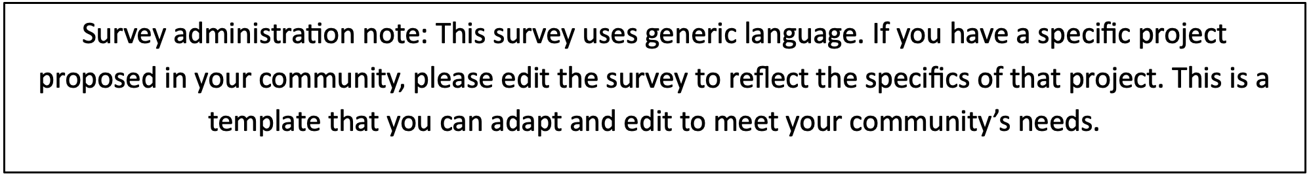

Community Renewable Energy Siting Survey

Introduction
This survey seeks to understand community opinions, concerns, and interests regarding large-scale solar, wind, and battery energy storage development. We define large-scale as any project that generates at least 1 megawatt (MW). 1 MW of solar uses approximately 7 acres. Modern wind turbines produce between 3-6 MW per turbine. Your feedback will help local decision-makers and organizations develop resources and strategies to support communities through the siting and permitting process.

Section 1: Awareness and Knowledge
- How familiar are you with the following technologies?
  - Large-scale Solar: [ ] Very Familiar | [ ] Somewhat Familiar | [ ] New to me
  - Large-scale Wind: [ ] Very Familiar | [ ] Somewhat Familiar | [ ] New to me
  - Battery Energy Storage (BESS): [ ] Very Familiar | [ ] Somewhat Familiar | [ ] New to me
- Are you aware of any solar, wind, or battery developments currently sited or proposed in your community? (Select all that apply)

Answer | Solar | Wind | Battery Storage
Yes, operating
Yes, proposed but not yet built
No projects that I know of
Not sure

- If yes, how close is the nearest project (sited or proposed) to your residence?
  - I can see it from my property
  - Less than 1 mile
  - Less than 5 miles
  - 5 to 10 miles
  - 11 to 15 miles
  - 16 or more miles

- What Town do you live in?
  - _____________

Section 2: Opinions on Energy Development

What are different types of solar systems?
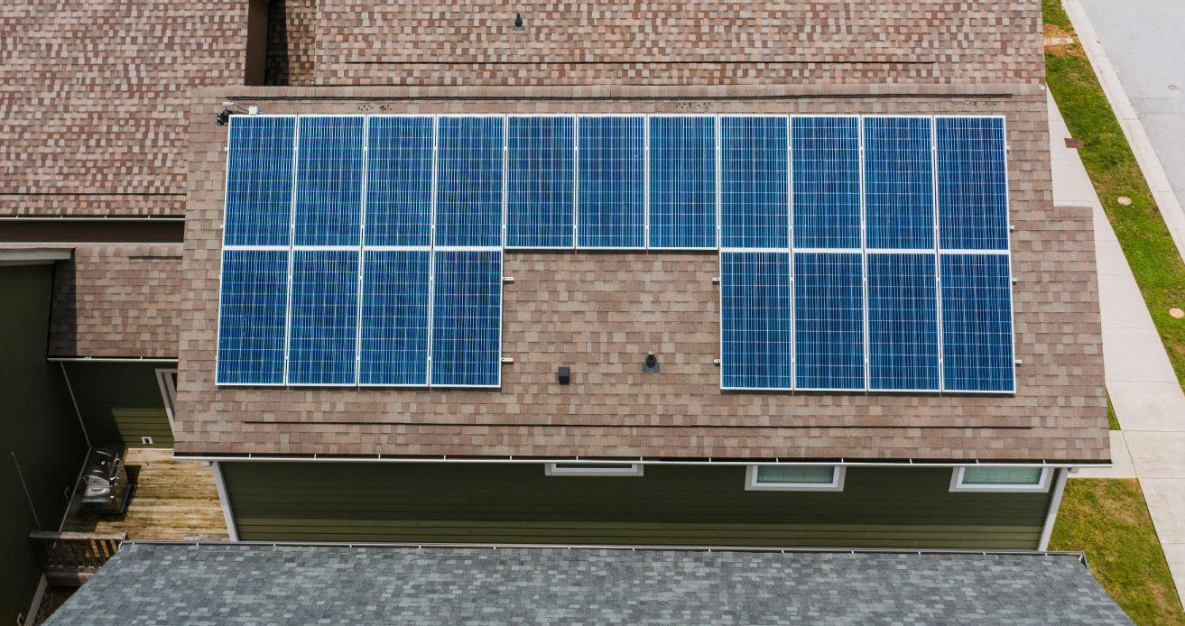
A residential rooftop solar system is a solar photovoltaic (PV) system where panels are mounted on the roof of a house or apartment.

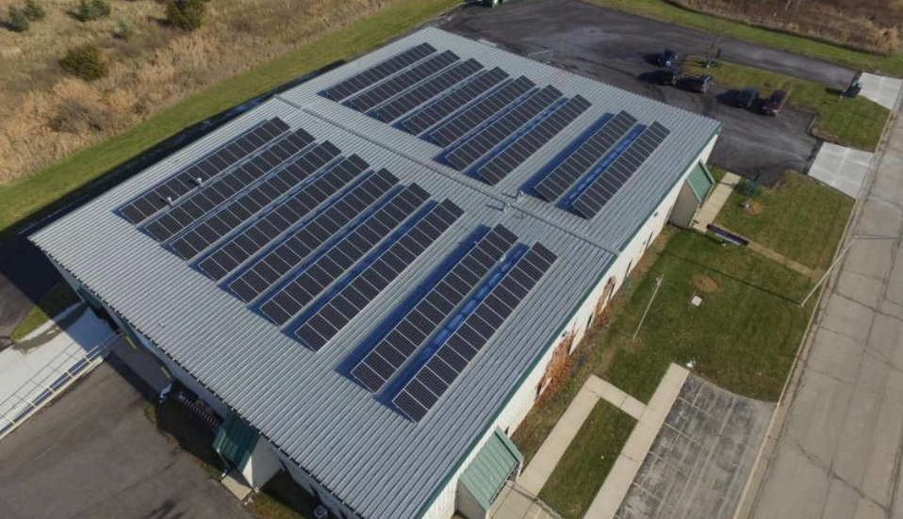

There are also commercial rooftop solar systems, which can be much larger depending on the size of the building.

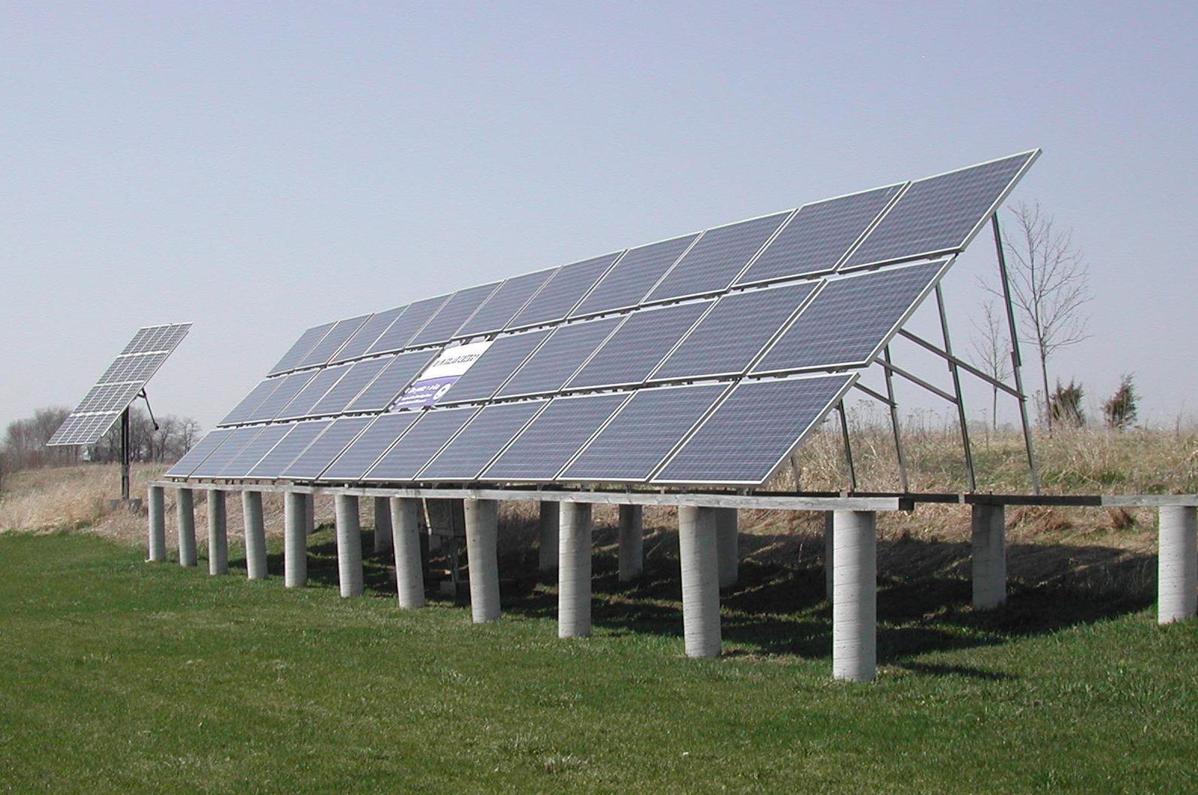

Ground mount solar systems can be used by homes and businesses that have land, and in larger community solar and utility-scale solar systems. The solar panels can be mounted on a racking system in the best direction for sun exposure.

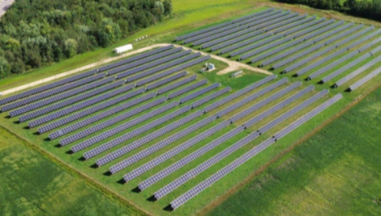

Large-scale solar is any project that is 1 MW or larger. 1 MW of solar uses about 7 acres. These can be hundreds of megawatts in size, using thousands of acres. These projects provide most of Wisconsin’s solar energy.

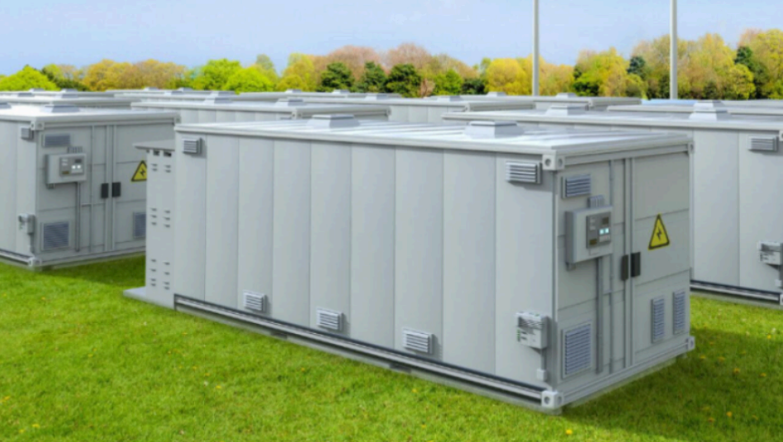

Energy storage is usually done with batteries, to provide consistent power to the grid when the sun isn’t shining or the wind is not blowing. Many new large-scale projects are built with battery energy storage systems as well.

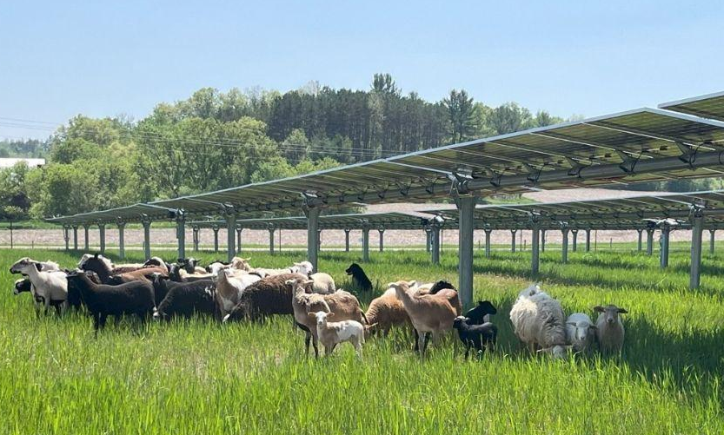

Agrivoltaics is the practice of combining solar panels and agriculture on the same land. It is possible to grow some crops or raise livestock under and around solar panels. Sheep grazing is the most common agrivoltaics activity in Wisconsin. Since they can help manage vegetation without changing the solar farm setup, sheep grazing can actually lower maintenance costs.
5. What is your level of support for the following types of projects on land in your community?

Answer | Strongly Oppose | Oppose | Neutral | Support | Strongly Support
Residential rooftop solar
Small large-scale solar (1–5 MW; approx. 7–35 acres)
Medium large-scale solar (5–50 MW; approx. 35–350 acres)
Large large-scale solar (50–100+ MW; 350+ acres)
Small large-scale wind (less than 15 turbines)
Large large-scale (more than 15 turbines)
Large-scale battery energy storage systems

- Comments____________________

Section 3: Perceived Impacts

6. Please rate the impact you believe a large-scale solar project would have on the following:

Topic | Negative | No Impact | Positive | Unsure
Farmland Preservation
Beauty of the Landscape (Aesthetics)
Wildlife and Habitat
Property Values
Human Health and Safety
Local Government Revenue (taxes & utility aid)
Local Job Market

7. Please rate the impact you believe a large-scale wind project would have on the following:

Topic | Negative | No Impact | Positive | Unsure
Farmland Preservation
Beauty of the Landscape (Aesthetics)
Wildlife and Habitat
Property Values
Human Health and Safety
Local Government Revenue (taxes & utility aid)
Local Job Market

8. Please rate the impact you believe a large-scale battery storage project would have on the following:

Topic | Negative | No Impact | Positive | Unsure
Farmland Preservation
Beauty of the Landscape (Aesthetics)
Wildlife and Habitat
Property Values
Human Health and Safety
Local Government Revenue (taxes & utility aid)
Local Job Market

Section 4: Benefits and Concerns

9. What do you see as the primary benefits of local renewable energy projects? (Select all that apply)
  - Jobs and economic benefits from construction
  - Local investment and utility aid
  - Greater energy independence
  - Reducing fossil fuel use and climate emissions
  - Improvements to local ground and surface water quality (solar)
  - Increased potential habitat for pollinators (solar)
  - Stable income source for landowners
  - Other (write in)
  - Comments: _____________________________________
10. What are your top concerns regarding new energy projects? (Select up to four)
  - Changes to the visual landscape
  - Land use / loss of agricultural land
  - Impacts on wildlife and hunting
  - Runoff, soil erosion, and other water and soil impacts
  - Disturbance of cultural artifacts or historical sites
  - Public health and safety
  - Disposal of equipment and land restoration at the end of the project life
  - Other (write in)
  - Comments: _____________________________________

Section 5: Information and Interests
11. What should be included in future energy projects to make them more acceptable?
  - Earlier community notification and engagement by the developer
  - Support for clean energy jobs training/education
  - Community benefit or developer agreements
  - Pollinator-friendly plantings
  - Agrivoltaics (combining solar with agriculture/grazing)
  - Screening plantings (trees/shrubs) to maintain visual landscape
  - Other (write in)
  - Comments: _____________________________________
12. Where do you get information about renewable energy and energy storage projects? (Select all that apply)
  - Newspaper
  - Social media
  - Local government meetings
  - Utility or project developer
  - Extension, university, or government publications
  - Friends, neighbors, or community organizations
  - Other (write in)
  - Comments: _____________________________________

