Model Solar
Zoning Ordinance
for Wisconsin Counties, Cities, Villages, and Towns
May 27, 2026

Developed by UW-Madison Division of Extension’s
RESET and Local Government Education Programs
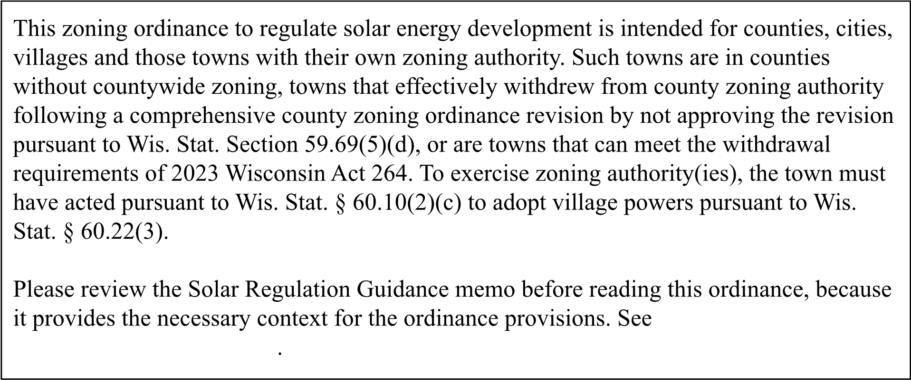
[MODEL ZONING-BASED ORDINANCE]
MODEL ANNOTATED LOCAL GOVERNMENT SOLAR ENERGY SYSTEM ORDINANCE
Prepared by the RESET Project and the Local Government Education Program
University of Wisconsin-Madison Division of Extension
May 27, 2026
COUNTY/CITY/VILLAGE/TOWN OF ______________, _________________ COUNTY SOLAR ENERGY SYSTEM ORDINANCE
Ordinance #_____________
1
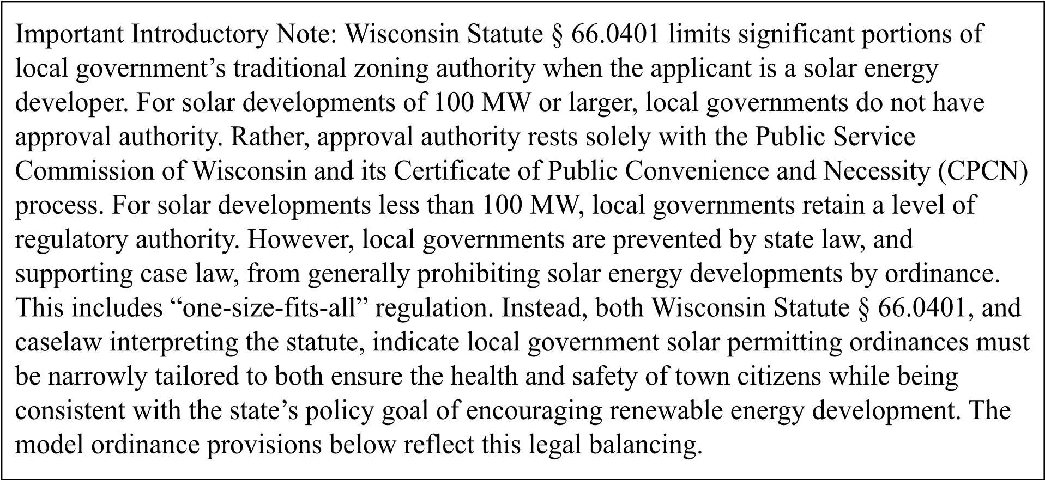
Section 1.01. Finding, Purpose and Authority
- Findings . The Wisconsin Legislature has determined that solar energy systems are an important part of the state’s renewable energy portfolio. Wisconsin Statute § 66.0401 sets the parameters for the county/city/village/town’s regulation of renewable energy systems, including solar. Wisconsin Statute § 66.0401 states local units of government may not regulate solar energy systems unless the ordinance: (1) serves to preserve or protect public health and safety, (2) does not significantly increase the costs of the system or significantly decrease its efficiency, or (3) allows for an alternative system of comparable cost and efficiency.
- Purpose. The purpose of this Ordinance is to incorporate requirements of Wisconsin Statute § 66.0401, and any applicable amendments thereto, to establish local regulations on the installation and use of solar energy systems complying with the applicable rules of the Public Service Commission of Wisconsin that preserve and protect public health and safety within the county/city/village/town by minimizing or preventing potential adverse off-site impacts from on-site and off-site
operations, and to promote the general welfare of the people of the County/City/Village/Town of ________________.
- Authority . This Ordinance is adopted under the powers granted to the County of
______________ by Wisconsin Statutes § 59.69/the City of _____________ by
Wisconsin Statute § 62.23(7)/The Village of ______________ by Wisconsin Statute § 61.35/The Town of __________________ by Wisconsin Statute §§ 60.61 - 60.62, and its authority under Wisconsin Statute §§ 66.0401 and 66.0403, and under other authority granted by the Wisconsin Statutes, including the town adoption of village powers under Wisconsin Statute § 60.10(2)(c). All subsequent amendments,

repeals, or recreations of state statutes relating to this Ordinance are incorporated herein by reference on their effective dates.
- Interpretation . The Wisconsin Court of Appeals has held that evaluating an application for a renewable energy system requires a case-by-case approach and that Wisconsin counties/cities/villages/towns may not set a one-size-fits-all scheme of regulatory requirements for solar energy systems. The state statutes require, and the Wisconsin Court of Appeals has also held, county/city/village/town regulatory requirements must be reasonable and based on “substantial evidence.”
Section 1.02. Applicability .
(1) This Ordinance applies to all Solar Energy Systems generating electricity within the County/City/Village/Town of ____________ designed for nominal operation at a capacity of 1,000 kilowatts (1 megawatt or more).
Section 1.03. Definitions .
- Agrivoltaics – A solar energy system co-located on the same parcel of land as agricultural production, including crop production, grazing, apiaries, or other agricultural products or services.
- “Construction activities” means initiation of any construction, land clearing, or land disturbance related to construction, installation, operation, or decommissioning of a solar energy system.
- CPCN – Certificate of Public Convenience and Necessity issued by the Public Service Commission of Wisconsin.
- CPCN – Permitted Solar Energy Generating System – A commercial solar energy system of 100 megawatts (MW) or more that is permitted by the Public Service Commission of Wisconsin under its Certificate of Public Convenience and Necessity Permit review process. A CPCN-Permitted Solar Energy Generating System is the principal land use for the parcel(s) on which it is located.
- Ground-mount – A solar energy system mounted on a rack or pole that rests on or is attached to the ground. Ground-mount systems can be either accessory or principal uses.
- Kilowatt – a unit of power equal to one thousand watts.
- Locally Permitted Solar Energy System – means facilities designed for nominal operation at a nameplate capacity of between one and less than 100 megawatts.
- Mature Trees – trees that have reached a stage in their growth cycle where they have achieved their full or near-full height, canopy spread, and overall form typical for their species. They are no longer in a rapid growth phase and have well-established root systems, trunks, and branching structures.
- Megawatt – a unit of power equal to one million watts, especially as a measure of the electrical output capacity of a power station.
- Owner – the owner of the solar energy system.
- Photovoltaic System – A solar energy system that converts solar energy directly into electricity.
- Solar Collector – A device, structure or a part of a device or structure for which the primary purpose is to transform solar radiant energy into thermal, mechanical, chemical, or electrical energy. The collector does not include frames, supports, or mounting hardware.
- Solar Energy – Radiant energy received from the sun that can be collected in the form of heat or light by a solar collector.
- Solar Energy System – Equipment which directly converts and then transfers or stores solar energy into usable forms of thermal or electrical energy, including but not limited to a device, array of devices, or structural design feature, the purpose of which is to provide for generation or storage of electricity from sunlight. This includes transmission facilities dedicated to the solar energy system.
- Solar Mounting Devices – Racking, frames, or other devices that allow the mounting of a solar collector onto a roof surface or the ground.
- Viewshed – a natural or historic environment that is visible from one or more viewing points.
Section 1.04. Conditional Use
(1) Solar energy systems are a conditional use in all zoning districts subject to certain requirements as set forth below.
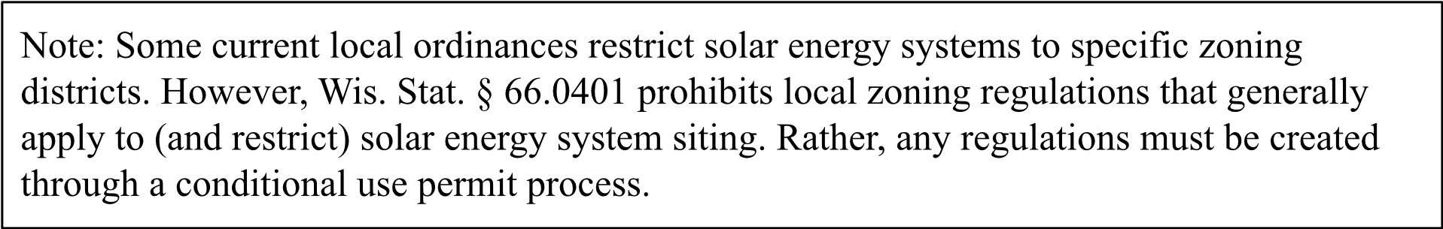
Section 1.05. CPCN-Permitted Solar Energy Generating Systems (100 MWs or Larger) . Ground-mount solar energy arrays that are the primary use on the lot, designed for providing energy to off-site uses or export to the wholesale market, shall meet the following requirements:

- Registration and Notice of Intent. All solar energy systems subject to the primary jurisdiction of the Public Service Commission of Wisconsin (PSCW) shall file a Notice of Intent to Construct with the county/city/village/town no later than five (5) business days after filing a CPCN application with the state.
- Local Coordination Packet. The Notice of Intent shall be accompanied by a Local
Coordination Packet identical to the application filed with the Public Service Commission of Wisconsin. The purpose of this local filing is to facilitate coordination regarding local road use agreements and other agreements, along with emergency services training.
- Project Narrative. The applicant shall provide a narrative of the proposed project, including a description of the subject property, address(es), parcel numbers, and any
unique circumstances identified during the Public Service Commission of Wisconsin review within the proposed project area.
- Information Requirements. The Notice of Intent shall contain the following for informational and coordination purposes:
(a) Final Site Plan: A copy of the site plan submitted to the PSCW, showing the location of all arrays, inverters, and substations. If the site plan submitted to the Public Service Commission of Wisconsin does not include the following informational items, then the following information shall be provided:
  - Existing and proposed improvements
  - Existing and proposed structures
  - Existing and proposed topography
  - Existing and proposed fencing
  - Existing and proposed utilities
  - All above ground and under ground components
  - Wetlands, waterways, ditches, and underground drainage system
  - Floodplain
  - Public roads, access roads, and internal roadways
  - Access locations and driveways
  - Setbacks identified in the site plan
  - Utility aid projections
  - Estimate of decommissioning costs by a third-party engineer qualified to make such an estimate
- Road Use & Haul Route Plan: Identification of all local roads to be used during construction and a pre-construction video/photo log of road conditions.
- Identification of three applicant contacts responsible for the site who are available to: (1) respond to questions regarding site management,including noise, dust or traffic complaints, (2) be contacted in emergencies, or (3) provide updates. This shall be updated annually.
- Other approvals. A copy of all necessary federal and state permits and approvals shall be submitted to the county/city/village/town within thirty (30) days of receiving such authorization(s).
- Preconstruction Filing Requirement. At least ninety (90) days prior to the construction of a CPCN-permitted solar energy system, the solar energy developer/owner shall file with the county/city/village/town a legal description or ALTA survey, an accurate map of the facility to be constructed indicating the location of said infrastructure, geographic information system information (GIS) showing the location of such infrastructure to be constructed, and current information identifying the owner(s) and operator(s), including designated representatives of the solar energy system.
- Emergency Management Plan: A plan developed in consultation with local Fire and EMS departments regarding battery storage locations and emergency shut-off procedures.
- Additional Permitting Requirements. Ministerial permits, including but not limited to driveway/access, culvert, erosion control and fire number, and processes, may be required under the county/city/village/town Code of Ordinances.
- Postconstruction Filing Requirement. Within (90) days of the date a Large Solar Energy Generating Facility commences operation, the owner shall file with the county/city/village/town an as-built description of the facility, an accurate map of the facility showing the location of all infrastructure, geographic information system information showing the location of said infrastructure, and current information identifying the owner(s) and operator(s), including designated contact(s), of the Large Solar Energy Generating Facility.
- Operator Ownership Change. Notice shall be provided to the county/city/village/town for any change in ownership of the Large Solar Energy Generating Facility (30) days prior to the effective date of the change and contact information of the new owner shall be included with the notice.
- Fee. An administrative fee may be charged to cover the cost of staff time for reviewing the road impact data and emergency response plan.
Section 1.06. Locally-Permitted Solar Energy Generating Systems (under 100 MW’s).
  - Permit Requirement: the solar energy generating system developer/owner shall obtain a conditional use permit, as well as a zoning and land use permit as required by either the county/city/village/town, as is applicable, prior to installing, constructing, or expanding a solar energy system.
  - Application Process: the solar energy developer/owner application shall be processed in accordance with the procedures set forth in county/city/village/town ordinance.
  - Permit fee: if not otherwise stated in a separate county/city/village/town fee ordinance, the solar energy developer/owner shall pay an application fee at the time the application is filed with the county/city/village/town based on the amount of time required to review the application. Fees shall be reasonably based on the municipal expense of reviewing and issuing the permit pursuant to Wis. Stat. § 66.0628.
  - Standards for Review: the standards for reviewing a permit application for a large-scale solar energy system are consistent with Wisconsin Statute §§ 66.0401 and 66.0403.
  - Application Requirements: the application for a conditional use permit shall include the following items as applicable to the project area:
    - A narrative of the proposed project, including a description of the subject property by legal description and/or ALTA survey, address(es), parcel numbers, and any unique circumstances within the project area.
    - A site plan, which shall include, but is not limited to, the following:
    - A scalable drawing showing the location of all drives, entrances, easement labels and locations, trails, and signs; panels, inverters, storage systems, and any other planned infrastructure;
    - Existing and proposed improvements
    - Existing and proposed structures
    - Existing and proposed topography
    - Existing and proposed fencing
    - Existing and proposed utilities
    - All above ground and underground components
    - Wetlands, waterways, ditches, and underground drainage system(s) if already mapped
    - Floodplain
    - Public roads, access roads, and internal roadways
    - Access locations and driveways
    - Setbacks identified in the site plan
    - Any other information reasonably required by the county/city/village/town that is relevant to the proposal.
- A plan showing an overhead view of all existing and proposed landscaping on the site, including the anticipated location, species, and size at time of planting and at maturity for all new plantings.
- Prior to construction, a grading and drainage plan, showing existing and proposed surface elevations, and proposed erosion control and stormwater management provisions focused on increasing infiltration and reducing runoff, minimizing soil compaction, and minimizing or eliminating soil grading during construction.
- A decommissioning plan, including an estimate of decommissioning costs.
- For Locally-Permitted Solar Energy projects of 50 MW or greater, Shared Revenue Utility Aid projections and estimated property tax reductions to the County, town(s), and school/special district(s).
- A project narrative describing the proposed project, including a quantitative summary of the acreage contracted by the Solar Energy Developer through lease agreements, along with any other documentation with affected landowners outlining any site-specific terms or conditions of development and assuring maintenance of land to be owned or used for common purposes, including, but not limited to joint development agreements and road maintenance agreements.
- Any other documentation as identified by the county/city/village/town zoning administrator and county/city/village/town planning and/or zoning committee to demonstrate compliance with state and federal law.
- Documentation evidencing cultural, archeological, and environmental analyses done by third parties, and associated permit authorizations as required by law if there is a recorded State Historic Preservation Office (SHPO), Wisconsin Historic Preservation Database (WHPD) or tribal site with a quarter mile of the proposed solar energy development.
- A complete list of neighboring parcels that have been notified by U.S. mail of the project that are located within 500 feet of the project boundary.
- Documentation of anticipated water and soil impacts from construction activities, materials and project, plans to mitigate the impacts, and a baseline testing and monitoring protocol to be implemented to assess such impacts.
- A plan outlining procedures for resolving noise complaints by owners of adjoining property or by the county/city/village/town.
- Identification of three applicant contacts responsible for the site who are available to: (1) respond to questions regarding site management, (2) be contacted in emergencies, or (3) provide updates. This shall be updated annually.
(6) Conditional Use Permit Application Review Criteria: in addition to conditional use permit criteria in other county/city/village/town ordinances, and consistent with Wisconsin Statutes § 66.0401, the review for a Conditional Use Permit shall address and consider the following on a case-by-case basis:
  - Reasonable construction standards, including phasing to limit area of disturbance, specific hours of construction to limit disruption to residents, and light pollution mitigation.
  - Maintenance and repair of damage to local roads due to project construction, including a Road Maintenance Agreement and financial assurance during the construction phase in the form of a surety bond, letter or credit, escrow account, reserve fund, parent guarantee, or other suitable financial mechanism.
(c ) Setbacks from participating and non-participating property lines, residential structures, unique adjacent land uses, and roadways, assessed on a case-by-case basis for each parcel affected.
- Screening or other measures proposed to diminish negative impacts on existing residential dwellings.
- Tree removal if construction of the solar energy facility includes proposed removal of mature trees.
- Ground cover to ensure proper erosion control and to manage runoff.
- Soil health measures, including perennial vegetation cover for the full operational life of the project, minimizing compaction for construction and post-construction periods, and other soil health practices.
- Woven wire f e ncing , designed for wildlife and livestock safety, with openings designed for small wildlife movement that is consistent with best management practices established by the Wisconsin Department of Natural Resources.
- Documentation of working with neighbors with property within 50 feet of the project boundary and/or with a residence within a minimum of 500 feet of the project boundary.
- An analysis of the potential for protecting prime agriculturally-suitable soils by siting the proposed solar energy development on a different portion of the subject property, if possible.
- To the extent feasible and practical, plans to use the land for both electricity generation and agriculture or conservation, possibly including but not limited to:
  - Grazing of livestock such as cattle, sheep, and/or chickens; or
  - Planting and maintaining pollinator-friendly native plant species and reduced herbicide applications;
  - Planting of crops.
- Mitigation of impacts to local environmentally sensitive species and habitats by following:
  - Best construction and design practices to minimize wildlife impacts, including wildlife permeable fencing to allow smaller wildlife access through facility fences; and
  - Best construction and design practices to allow larger wildlife access through facility fences or natural movement around facility fences.
  - Where feasible, solar energy systems are encouraged to be located on previously disturbed lands or areas with limited ecological value, and to avoid undisturbed natural areas. Applications for a Solar Energy System CUP shall include an existing conditions map. The system footprint shall avoid undisturbed natural areas unless the applicant provides substantial evidence that:
    - No feasible alternative location exists on the subject property that consists of previously disturbed land; and
    - The proposed location minimizes the fragmentation of contiguous forest or grassland habitats to the maximum extent practicable.
- Dust mitigation measures.
- Potential adverse impacts on cultural and environmental resources.
- Equipment-related sound mitigation measures that keep operational noise levels at property line(s) below a threshold of no greater than the industry standards outlined by the Public Service Commission, possibly including but not limited to:
  - Equipment relocation further from existing residences, schools and businesses;
  - Noise reduction, to the extent practicable, using quieter equipment;
  - Sound shielding technology;
  - Sound filtering technology; and,
  - Noise suppression and blocking with building enclosures or barrier walls.
- Operational lighting standards.
- Mitigation plans for any damaged soil drainage infrastructure.
- Mitigation plans for any damage to surface water conveyance infrastructure, such as grassed waterways.
(s ) Fire hazard mitigation plans, including:
- Battery-related fire suppression design and chemical release containment design;
- Clean-up and monitoring of any fire-related chemical releases; and
- Applicant-provided no-cost emergency response training for local fire departments and emergency medical services (EMS) providers.
- Road maintenance agreement outlining the process of pre, ongoing, and post-construction inspections of roads for construction deliveries and that outlines the applicant’s responsibility to repair any material damage to a road that is documented to be caused by project construction.
- Decommissioning plan and financial assurance proposal.
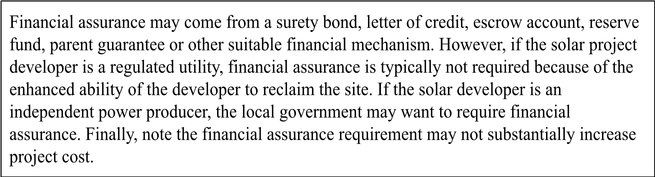
- Compliance with state and federal laws, as may be applicable.
- A description of any additional community benefits the applicant is proposing for the county/city/village/town, including but not limited to those identified
in a joint development agreement, good neighbor agreement, road maintenance agreement.
- Other provisions consistent with Section 1.06(2) above.
Section 1.07. Zoning Permit Requirements for Generating Systems Under 100 MWs.
- Permit Requirement. The owner must apply for and receive a Zoning Permit from the Department before installing, constructing, or expanding any Locally-Permitted Solar Energy Generating Facility.
- Application Process. The application for a Zoning Permit shall be processed in accordance with the procedures set forth in county/city/village/town ordinance.
- Permit Fee. Unless otherwise stated in a fee ordinance adopted by the county/city/village/town, the owner shall pay an application fee at the time the application for a Locally-Permitted Solar Energy Generating Facility is filed with the Department. Fees shall be reasonably based on the municipal expense of reviewing and issuing the permit pursuant to Wis. Stat. § 66.0628.
- Permit Expiration. A Zoning Permit issued by the Department expires if construction of the Locally-Permitted Solar Energy Generating Facility is not commenced within 24 months from the date of the permit, or if the
Locally-Permitted Solar Energy Generating Facility is not installed and fully functioning within 12 months from the date construction begins. A 12 month extension may be granted.
- Application Requirement. The application for a zoning permit shall include the following items as applicable to the project area if materially different from the information submitted with the request for a conditional use permit:
- A narrative of the proposed project, including a description of the subject property by a legal description or ALTA survey, address(es), parcel numbers, and any unique circumstances within the project area.
- A site plan, which shall include a scalable drawing showing the location of all drives, entrances, easement labels and locations, trails, and signs; panels, inverters, energy storage systems, and any other planned infrastructure; vision clearance triangles; floodplain(s); wetland(s); and shoreland zone boundaries.
- Supporting documentation addressing the review criteria in Section 1.06 (6) of this ordinance and any other relevant update, if not already submitted.
- Maintenance Log. Owner/operator, at the owner/operator’s sole expense, shall maintain and provide the county/city/village/town at least annually with a maintenance log for the solar energy generating facility. The log must contain the following information regarding any maintenance performed: 1) date and time maintenance was performed; 2) nature of the maintenance performed; and 3) reason(s) for the maintenance. The county/city/village/town may retain such consultants or experts as it deems necessary to assess and determine whether the solar energy system facilities are compliant and/or to assess whether the solar energy system facilities are being maintained in good repair and operating condition. An owner/operator shall pay for all reasonable costs incurred by the county/city/village/town in connection with monitoring compliance during construction and operation.
- Foundations. Owner shall ensure foundations are certified by a qualified engineer so that foundation and design, and solar panel racking, are within accepted professional standards given local soil and climate conditions.
- Equipment Capability. Owner shall ensure equipment has the capability to withstand extreme weather events, with a preference that components be listed by the Underwriters Laboratory and comply with Section 691 of National Fire Protection Association (NFPA) 70, National Electrical Code.
- Electrical Inspection. Post construction, the owner shall conduct a system electrical inspection, confirming the project was correctly and completely grounded, with no stray voltage issues. Confirmation shall be validated by an independent engineer review of electrical plans and equipment inspection, as governed by the NEC and NESC.
- Contacts. Owner/operator shall identify three contacts responsible for the site who are available to: (1) respond to questions regarding site management, (2) be contacted in emergencies, and (3) provide updates. This list shall be updated annually and as needed due to personnel changes.
- Additional Permitting Requirements. Additional permits and processes may be required under county/city/village/town ordinance.
- Operator Ownership Change. Notice shall be provided to the county/city/village/town for any ownership change of the Locally-Permitted Solar Energy Generating Facility at least 30 days before the effective date of the change.
- Other Approvals. If required by the CUP, a copy of all necessary state and federal permits and approvals shall be submitted to the county/city/village/town within 90 days of receiving such authorizations.
- Postconstruction Filing Requirement. Within 90 days of the date a
Locally-Permitted Solar Energy Generating Facility commences operation, the owner shall file with the county/city/village/town an as-built description of the facility, an accurate map of the facility showing the location of all infrastructure, geographic information system information showing the location of said infrastructure, and current information identifying the owner(s) and operator(s), including designated contact(s), of the Locally-Permitted Solar Energy Generating Facility
- Battery Energy Storage System. If battery energy storage systems are included in the solar energy development, in addition to any requirements in a county/city/village/town battery energy storage system ordinance:
  - The system shall be UL 9540 and NFPA 855 compliant to prevent fires and chemical leaks as part of a conditional use permit.
  - The system shall be set back 1,500 feet from residential, business, municipal, school or town structures, and 1,000 feet from a drinking water system. 1. Separate containment enclosures that include the following goals:
    - Enclosure size capacity containment of 150% of the battery energy storage system.
    - Sufficient fireproofing for connecting electronic wires, preventing the spread of fire from one structure to the next and from the battery energy storage system to the substation.
  - Battery management protocols including:
    - Labeling of battery energy storage system container with a date of first usage via a stamped metal nameplate with serial number.
    - Upon the end of its serviceable life the battery energy storage system container shall be removed from the site and recycled at owner/operator’s expense.
    - The owner/operator shall give an annual report to the county/city/village/town documenting which batteries are near the end of their lifecycle, including current physical location of the battery and its serial number.
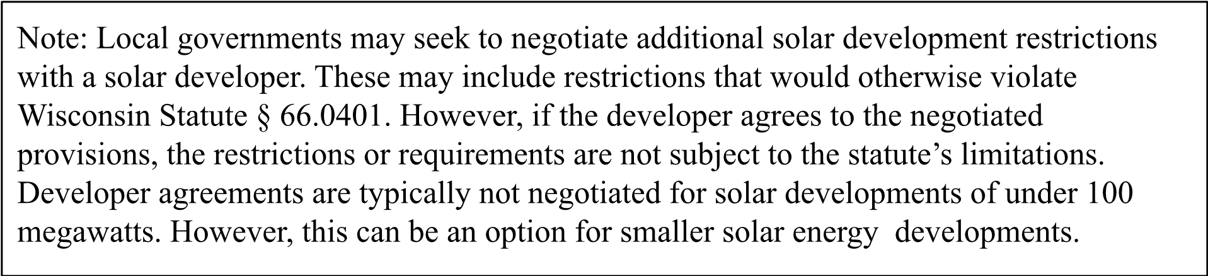
Section 1.08. Effective Date. This Ordinance shall take effect upon passage and publication as provided by law.
Approved by the County Board of Supervisors/City Council/Village Board/Town Board on this ____ day of ___, ___.
County/City/Village/Town of
______________________________
By: ______________________
County Board Chair/City Mayor/Village President/Town Chair
By: ______________________
Clerk
Date Approved: _________________
Date Published: _________________
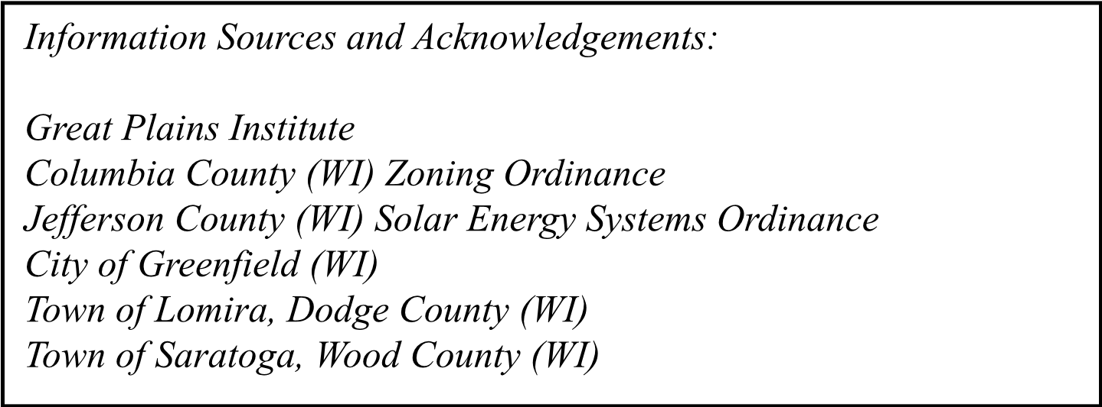

Author
Bill Oemichen, J.D., is UW-Madison Extension’s Local Government Education Professor of Practice-Law. Bill is a member of the State Bar of Wisconsin, the State Bar of Minnesota, and the Law Society of Alberta Canada.

Reviewers
Brian Ross, Great Plains Institute Vice President, Renewable Energy
Carol Nawrocki, Wisconsin Towns Association Assistant Director
Christina Anderson, Land + Water Associate Director
Diane Mayerfeld, UW-Madison Extension Outreach Specialist
Jessy Bradish, UW-Madison Extension Renewable Energy Specialist
Katie Nekola, Clean Wisconsin General Counsel
Nolan Stumpf, OneEnergy Renewables Manager, Development
Peter Levi, The Nature Conservancy Wisconsin Chapter Director of Conservation
Science
Rick Coelho, Clean Wisconsin Rural Energy Campaign Manager
Sherif Halaweish, RENEW Staff Attorney
Stacy Schumacher, Public Service Commission of Wisconsin
Tara Greiman, Wisconsin Farmers Union Director of Conservation and
Stewardship
Tiana Snyder, The Nature Conservancy Renewable Energy and Climate Social Science Fellow
For more information, visit go.wisc.edu/reset or contact RESET at reset@extension.wisc.edu

Funding Acknowledgement
This report is based upon work supported by the U.S. Department of Energy Office of Critical Minerals and
Energy Innovation (CMEI) through the Reliable Energy Siting through Technical Engagement and Planning (R-STEP) program. R-STEP is administered with support from the Partnership Intermediary Agreement (PIA) that the U.S. Department of Energy (DOE) has established with ENERGYWERX.
The views and opinions of authors expressed in this report do not necessarily state or reflect those of the United States Government or any agency thereof.




